Services offered in Surgery  - Ante-Natal Services  - Cervical Cytology  - Child Health Surveillance and Childhood Vaccinations  - NHS Health Checks  - Palliative Care  - Travel Vaccinations  - Health Promotion  - Long term condition monitoring  - Flu (Influenza)and Pneumococcal Vaccinations  - Long Term Conditions Monitoring  Patient Confidentiality & Data Protection  The Practice is compliant with the Access to Medical Records Act 1990 and the Freedom of Information Act 2000. It is registered under the Data Protection Act 1998.  It also conforms to the Common Law Duty of Confidentiality and adheres to the NHS Code of Practice when sharing information between Professionals in support of patient care.  Patient information is accessed only by staff for providing care and managing your treatment. You have the right to request information about who can access your data and how it is used. For details contact the surgery.  Change of details  If any of your details change, please inform the surgery straight away  Call Recording  Patients should be aware that ALL calls in to and made from the practice are recorded. | Patient Participation Group  We run a patient participation group this helps to improve communication between patient and practice. It helps us to ensure that the services we offer meets the need of our patients. We are always looking for new patients to join our group, share ideas on how things could be changed or improved. If you are interested in becoming a member please ask at Reception for further details.  Reasonable Adjustments  We are committed to ensuring that all our patients can access our services comfortably and equally. If you have any specific needs or require reasonable adjustments to use our services, please let us know and we will do our best to accommodate your needs.  Clinical Team  Dr Anant Sharma (GP Partner)- MBBS, MRCGP  Dr Laura Harvey (GP Partner)- BM BS, MRCGP, FRCA (2012)  Dr Natalie Turner MB ChB, MRCGP  Dr Narinder Dhillon MBBS, MRCGP  Bonnie Butler PN- RGN  Carol Mace HCA- NVQ LVL 3 in Health and Social Care  Practice Staff  Jenna Biddulph Practice Manager  Lisa Dugmore Secretary  Hema Sharma-Lewis Admin  Wendy Smith Senior Receptionist  Susan Storr Receptionist  Amy Hill Receptionist  Rebecca Deakin Receptionist  The Practice is fully accessible to wheelchair users and provides a disabled toilet facility. |     Bilston Family practice  Bilston Health Centre  Prouds Lane, Bilston, WV14 6PW  Telephone: 01902 405200  www.bilstonfamilypractice.nhs.uk  PRACTICE OPENING TIMES  Monday, Tuesday, Wednesday & Friday 8.30am – 6.30pm  Thursday 8.30am – 1.00pm  Register with the practice  The surgery operates on an open list policy. To register please call into the practice or register online via our website. Our practice boundary can be found on our website.  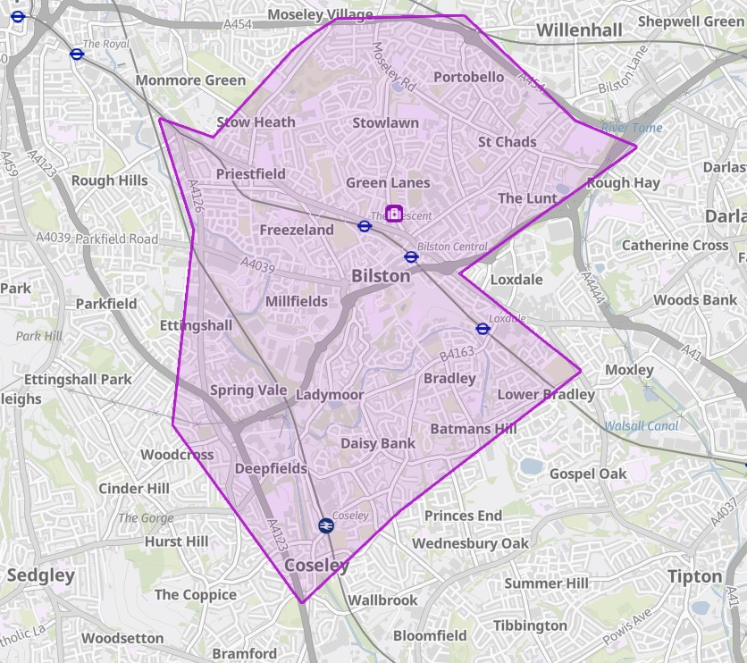
Booking a routine appointment  You can book a routine appointment either in person at Reception or by telephoning the Practice. You can also book online via patient Access (you will need to register with us first). Reminders are sent via SMS  Appointments are generally available 4-6 weeks in advance.  You can express a preference to see a particular clinician, and we will do our best to accommodate your request. However, please note that this may not always be possible due to availability of doctors.  Urgent Appointments  We offer urgent appointments that can be booked on the day. Our reception team are trained to ask about your condition to enable them to navigate you to the most appropriate clinician or service. Please disclose the nature of your problem with them to enable them to help you.  Arriving Late/Cancelling an appointment  Please ensure you arrive on time for your appointment. If you are late for your appointment the clinician may not be able to see you and you may have to rebook.  Please notify us as soon as possible if you cannot make your appointment, so that it can be offered to another patient.  You can cancel via SMS.  Complaints/ Feedback  We always aim for high standards and strive for continual improvement. If you have feedback about the service that you received you can let our staff know, put this in writing marked for the attention of the practice manager, visit our website or contact  Email: bcicb.time2talk@nhs.net  Tel: 0300 0120 281 | Home Visits  If you require a home visit please call us before 10.30am. Requests should only be made if the patient is bed bound, too ill to attend the surgery or only to be moved by ambulance.  Non-availability of public transport is NOT a valid reason for a home visit.  Repeat Prescriptions  You can order repeat prescriptions in person at the surgery, via patient access or by contacting your normal chemist. Please allow 48 hours for repeat prescriptions to be issued. We DO NOT take prescriptions over the telephone.  Chaperone Service  Chaperones are available to support you during intimate examinations. Please ask the Doctor/Nurse for this service  Interpreters  If you require an interpreter for your appointment please let the reception team know at time of booking. If you are booking online please book a double appointment to allow for this.  Removal of Patients  The surgery operates a zero-tolerance policy on verbal and physical abuse towards any member of our team. Any patient who commits an act of violence or behaves in an aggressive or threatening manner to staff will be removed from the practice list.  If you fail to attend 3 scheduled appointments in a 12-month period we reserve the right to remove you from our practice list, following appropriate warnings, as this constitutes as a breakdown in Doctor Patient relationship. | Accountable GP Information  Every patient is assigned an accountable GP to oversee their care. All patients aged over 75 will have a named GP. You can find out who your named GP is by asking at reception, this information is also shown on your repeat prescription form.  Patient Consultation Rights  You can request a consultation if:  - Aged 16-75 and have not attended a consultation or clinic in the last 3 years.  - Aged 75 and over and have not had a consultation in the last 12 months  Outside of surgery opening hours  If you become unwell outside of our opening times please call the NHS Out Of Hours Service on 111. Alternatively, you could visit your local Urgent Care Centre located above A&E at New Cross Hospital, Wolverhampton Road, Heath Town, WV10 0QP.  Core hours  The Practice is open during core hours for your healthcare needs. On Thursday afternoons (1pm-6:30pm), alternative arrangements are in place, and patients can contact Wolverhampton Doctors On Call Tel: 01902 902613 for access during this time.  Enhanced Access  We offer extended access to appointments through our Unity Hub based at Pennfields Medical Centre, Upper Zoar St, Wolverhampton, WV3 0JH.  Appointments are available weekday evenings 6.30-8pm and weekends 8-2pm. These can be booked by our reception team or by calling directly on 01902 446688 during their opening hours.  UPDATED: 28/01/2025

